*Ananyaa Shahi, Kiran Ranganalli, Shaik Faiz Ahmed*

*Group 5*

*Group Project Report*

Exploratory Data Analysis

**Introduction**

Founded as a DVD rental service Netflix has materialized into a global streaming giant and is currently shaping the digital entertainment landscape. They offer a diverse and extensive library of TV shows, movies, documentaries, and original content across various genres. Subscribers have the flexibility to watch content at their own pace, anytime and anywhere, on a wide range of devices, from smart TVs and laptops to smartphones and tablets.

Their content is available in over 190 countries. They employ sophisticated algorithms to analyze viewing habits and suggest content tailored to individual preferences, enhancing the overall user experience.

The above-mentioned facts helped us decide on this dataset. Given Netflix’s relevance, popularity, and relatability, since it has a massive consumer base, it became our first choice for creating this exploratory data analysis group project. Its practical application can assist various stakeholders, including marketers, content creators, and industry analysts, providing actionable insights into the streaming market.

**Data Description**

Netflix has over 8000 movies or tv shows available on their platform, as of mid-2021, they have over 200M Subscribers globally. This dataset encompasses 12 key columns that capture the multifaceted aspects of TV and Movies added onto Netflix each year. This tabular dataset consists of listings and details such as -

* Cast
* Directors
* Ratings
* Release year
* Duration
* Type
* Show ID
* Title
* Country
* Data Added
* Listed In
* Description

**Scope of Analysis**

How does the distribution of content (movies and TV shows) on Netflix vary over time and across different countries, and genres, what insights can be derived regarding the platform's content strategy and global audience preferences?*?”* Our visualizations have helped us answer this driving question completely.

**Visualization 1**

For our first visual, we decided to plot total movies and tv shows by country. Following were the inferences we could derive from it:

**Content Hub** - USA, India, United Kingdom, Japan, and Canada are the top 5 countries acting as major production hubs.

**Market Saturation –** From the previous inference, there can be another indication that the above-mentioned countries have a more robust and established content creation industry.

**Cultural Diversity** – Barring a few countries, Netflix is providing content from most of the nations, suggesting a commitment to providing a global and culturally rich content library.

**Market Expansion Opportunities** – Most of the African countries like South Africa, Kenya and Ghana present opportunities for market expansion and strategic content acquisition.

**Visualization 2**

For our second visualization, we plotted the top 15 genres of Netflix. Below are our inferences:

**Dominant Genres** – We can identify Dramas, Documentaries and Stand-Up as the Top 3 genres. This can help Netflix decide on their content creation and acquisition strategies.

**Cross Genre Appeal** – International movies, Drama and Comedy are a few of the most recurring genres. It suggests that movies with combinations of these cross genres resonate well with viewers.

**Diversity of Genres** – Assessing the diversity of genres in the top 15, we see a well-rounded content library that caters to a broad audience with varied interests.

**Visualization 3**

For our third visualization, we plotted the number of shows added over the years in Netflix. The journey of Netflix's content releases over the past years there by highlighting some interesting trends and shifts:

* Starting from 1990, a beginning year for Netflix, where there were very few numbers of shows and movies has been released through CD’s or DVD’s later, we can see that gradually a greater number of shows were added and from this trend major jump has been observed in 2015 where approximately 500 shows and movies were added yearly
* 2018 is observed to be a record-breaking year where 1147 shows were added to its library.
* Despite facing pandemic and global challenges in 2019 which caused notable disruptions to the world Netflix continued to deliver over 950 shows from this data it can be said that the previous content created by the creators over the years had been released during this year
* However, later in 2021 we can see from the graph that the trend has decreased. There were only 592 shows released, suggesting that creators might have had a shortage of content due to COVID. This shift prompts us to consider the factors influencing content creation and the evolving landscape of streaming services.

**Visualization 4**

For our fourth visualization, we conduct an analysis involving the relationship between video duration and audience engagement:

* We found a compelling correlation between the length of videos and the number of ratings they receive, that will provide valuable insights for content creators and strategists.
* The visual showed that videos between the range 70 – 90 minutes (about 1 and a half hours) have the greatest number of ratings. Also, videos with more than 100 minutes (about 1 and a half hours) have received a smaller number of ratings compared to the ones with 70 to 90- minutes range.
* Also, the videos lasting less than 70 minutes have received lower number of ratings. From this observation we can say that viewers are more likely to give feedback when they invest moderate time in watching a video. Shorter video formats or too long videos may not always prompt viewers to provide ratings consistently.
* Understanding this correlation is not just about numbers; it is about strategic content planning. This analysis might serve as a valuable tool for content creators. It empowers them to make informed decisions about video duration, optimizing the potential for audience engagement and the success of their content.

**Visualization 5**

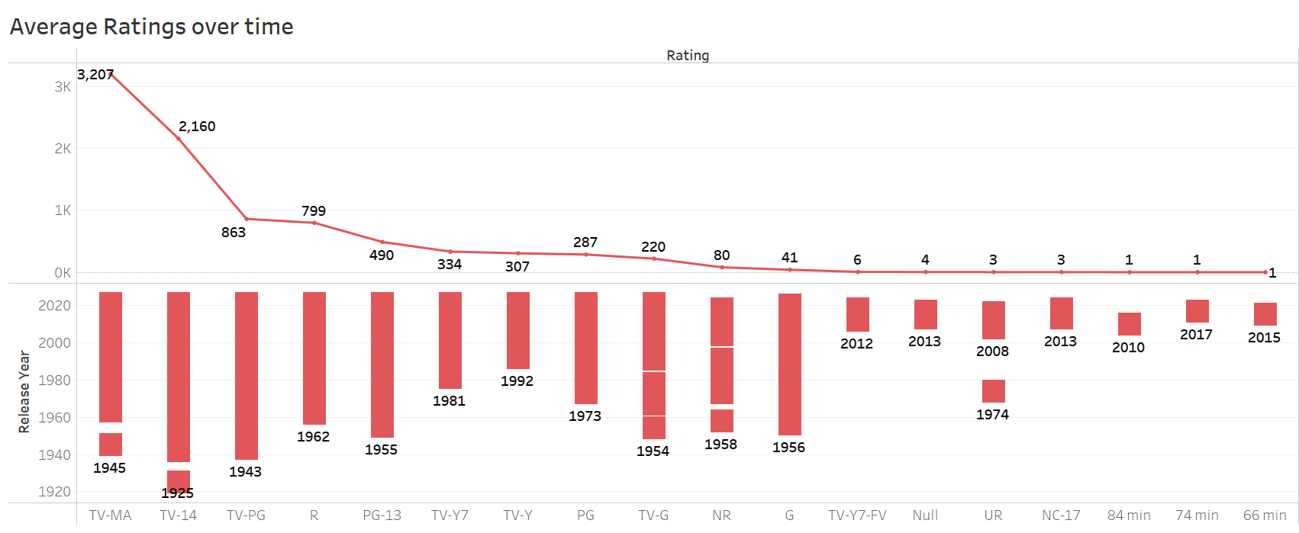

**User Engagement and Content Ratings**:

Understanding how content ratings affect us goes beyond just looking at numbers. It reflects the dynamic interaction between viewers and the content they choose. As we explore the graph, each bar not only signifies the numerical frequency of specific ratings but also speaks volumes about user engagement and content popularity.

**Viewer Preferences**:

The fact that some ratings are more popular in certain years gives us interesting clues about what viewers like. For instance, a rise in TV-MA content might indicate a preference for mature and thought-provoking narratives.

**Evolution Over Time**:

The fluctuation in the highest-rated content each year tells a story of the evolving landscape of viewer choices. This evolution could be influenced by cultural trends, or the emergence of new genres.

**Content Diversity**:

Observing the diversity of ratings represented in the graph highlights the richness of content available. From family-friendly G-rated shows to mature TV-MA content, the range of shows and movies is for everyone and has different things that people like.

**Dashboard**

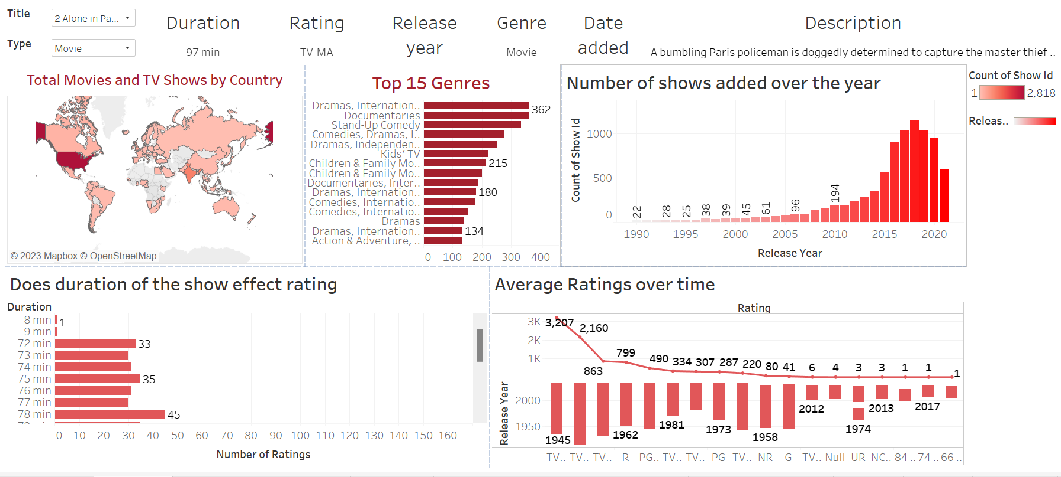

We can discover the world of Netflix through this dashboard. By using the map to see where movies and shows are loved globally. The bar chart reveals the top 15 genres which offer insights into what viewers enjoy. Track Netflix's growth with the dynamic line chart displaying the number of shows added over the years. We can explore the relationship between show duration and ratings through a line chart. Lastly, grasp content quality evolution with the Average Ratings Over Timeline chart, unveiling trends in audience reception. Each visual insight provides a unique window into Netflix, helping users make informed choices and understand the platform's changing content strategy.

**Conclusion**

In conclusion, our exploration of Netflix content through the dashboard sheds light on what viewers like, how Netflix plans its content, and how the platform has changed. The map shows where movies and shows are popular globally. The top 15 genres tell us what kinds of shows people enjoy the most. Tracking the number of shows added over the years gives us a history of how Netflix has grown. Looking at how show duration and ratings relate tells us what viewers prefer in terms of length and engagement. Also, the average ratings over time chart helps us see how audience reception and content quality have changed over the years. These visuals help us understand Netflix better.